
Identifying Societal Indicators of Violent and Sexual Crime
D. J. Sourbag, C. Vijn, K. Morriën
Faculty of Economics and Business Economics, Amsterdam School of Economics
Abstract
…

Introduction
…

Data cleaning

Initial selection of features
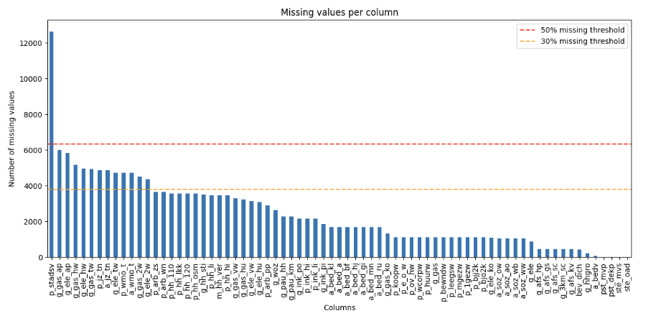
For the initial selection of features, we imposed two missing value thresholds: a strict cutoff at 50% missing data, above which features are removed, and a 30% threshold, below which features remain in the dataset.
However, several features fall within the 30-50% missing ratio, and a decision had to be made whether to remove them or not. A selection of these features contains information about household gas and electricity usage, where the features distinguish in different types of housing. As we found no relevant literature about a possible relation between gas/electricity use and any kind of criminality, all associated features were removed from the dataset. Another two features that fall in this 30%-50% missing ratio consider child service metrics, where one is the absolute count of young people in the neighborhood receiving childcare services and the other is a relative proportion of children receiving child services. Although child service is known to correlate with later contact with the justice system at the individual level (Fallesen, 2021 [1]), and individuals who have experienced child protection system involvement are over-represented in criminal justice systems (S. Baidawi et al., 2024 [2]), no literature was found with a definitive relation between child service on neighborhood-level and criminality. Since there does exist some relation between the two features and our target variable, we decided to keep both. The last two features that fall in the 30%-50% missing ratio concern wmo client metrics, i.e. clients receiving social support under the Social Support Act. J. Verbruggen et al. (2015) [3] found that both work and income support for men are associated with a reduction in offending rates, while for women only work reduces offending, but receiving income support (especially disability benefits) is associated with a higher offending rate. Because of this relation we decided to keep the last two features in our analysis as well.

Determination of target variable and outlier removal
The target variable in this study is the total number of violent and sexual crimes per thousand residents. The CBS dataset provides the absolute number of violent and sexual crimes, and the population count at neighborhood level. The target variable had to be manually constructed as:
$$Crimes per 1000=\frac{total violent and sexual crimes}{Population}*1000$$
Evidently, after cleaning both total violent and sexual crimes and population had to be excluded from further analysis.
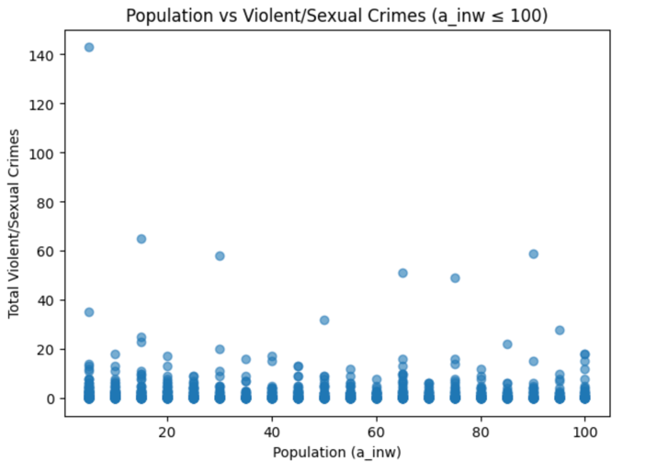
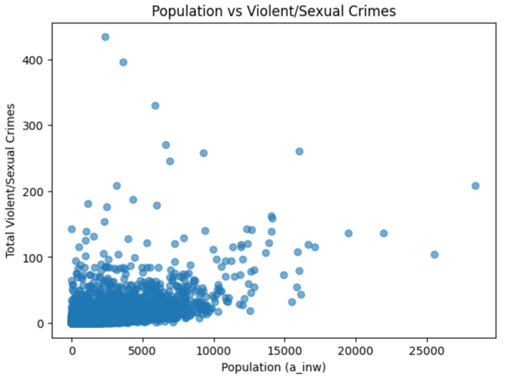
In a subset of neighborhoods, the reported population was zero. Division by zero caused infinite target values and consequently useless observations. Therefore, only neighborhoods with a population count greater than zero were taken into account when constructing the target variable. A second problem arrived in cases where the population of a neighborhood was low relative to the number of recorded violent or sexual crimes, or even lower.
As can be seen in the scatterplots above, there are several cases where the denominator is relatively small, and the numerator remains non-zero. For larger neighborhoods crime rate seemingly behave as expected, but in very small-population areas only a few criminal incidents could lead to disproportional high crime rates. The per thousand crime rate blows up resulting in absurd large target values, in no way giving a meaningful representation of reality. These outliers would cause problems later, and an upper bound had to be determined.

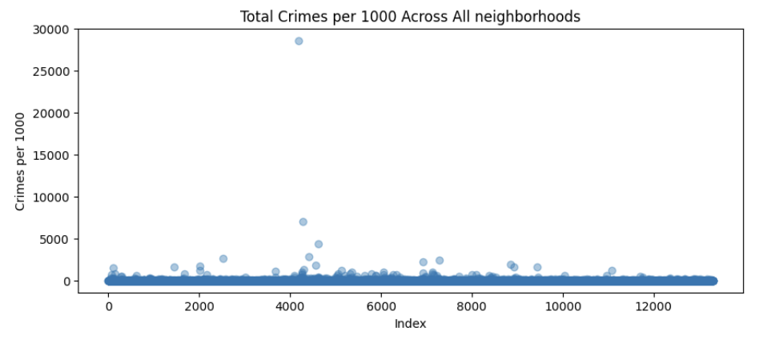
When plotting the total crimes per 1000 against the index we can clearly see this is the case. Although most observation fall within a realistic range, there are some serious outliers, in some cases eve exceeding 5000 crimes per thousand residents. To prevent these outliers from causing problems in further analysis we applied a IQR based upper bound. The upper quartile was defined as the 95th percentile to avoid influence of heaviest outliers, and the upper bound was calculated as:
$$Upper bound=Q3+1.5*IQR$$
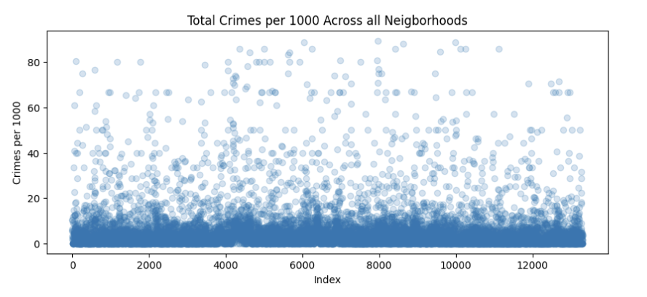
Where the lower quartile was the 25th percentile. Out of an initial 12,381 rows, 321 observations were removed, resulting in a cleaned dataset of 12,060 rows with the following distribution across all neighborhoods.

Regression / selection of most important features

Clustering (idk)

Literature Review

